Metro Area Continuum of Care for the Homeless
2017 Renewal Project Supplementary Data Form
Overview
Every CoC funded program is ranked and tiered annually per HUD guidance. The purpose is to ensure that HUD funded programs are providing the highest quality housing and services and that the programs are focused on achieving outcomes to end homelessness.
Project Scoring
Each CoC funded program seeking renewal funding in the FY2017 competition will be scored on their outcomes in addressing the HUD Performance Measures, adherence to HUD policy priorities, as well as their capacity to operate a CoC funded program.
New Process for FY2017
In order to improve accuracy, efficiency, and transparency, this year MACCH has instituted changes in the score card itself and in the process for completing the score card. For FY2017, the process will include the submission of information through this Supplementary Data Form.
Instructions
Please review this form fully well before the submission date, which is xx/xx/2017.
Questions on this form are numbered to correspond to the criteria numbering on the 2017 Project Renewal Score Card.
Please follow the instructions provided next to each question included on this form to ensure that the required information is included and the reviewer is aware of which documents have been submitted.
If a requested document is not available for submission, use the space provided to explain why it is not.
- The 2017 Renewal Project Supplementary Data Form and all other requested attachments should be named according to the naming conventions specified.

- The Renewal Project Supplementary Data Form should be named as follows:
“[Project Name]_SDF”
- All other Attachments should be named per the Attachment Checklist on Page 9 of this document
- All documents should be emailed to: macch.ne501@gmail.com
Questions
Any questions about this form may be directed to: Lisa Vukov, Assistant Director, Metro Area Continuum of Care for the Homeless (MACCH), lvukov@unomaha.edu, 402-980-8394.

Supplementary Data Form
Project Contact Information

Date: | Click or tap to enter a date.
Project Name: | Click or tap here to enter text.
Agency Name: | Click or tap here to enter text.
Contact Person: | Click or tap here to enter text.
Email: | Click or tap here to enter text.
Phone: | Click or tap here to enter text.

General Information Criteria
1. Project Type
Which type of project are you seeking to renew?: ☐ PSH ☐ RRH ☐ TH
Is this a DV program?: ☐ Yes ☐ No
Performance Outcome Criteria
For criteria 2-6, APR outcome data will be generated by HMIS and will cover a common year for all projects, October 1, 2015 to September 30, 2016. This year is consistent with the HUD System Performance Measures against which the CoC as a whole is measured.
Note: for DV programs, a performance reporting data form will be provided based on APR outcome metrics.
2a. Retention of Permanent Housing – PSH and RRH
If your project experienced any irregularities that negatively impacted your project’s performance on this measure, you may provide an explanation below for consideration:
Click or tap here to enter text.

2b. Exit to Permanent Housing – TH
If your project experienced any irregularities that negatively impacted your project’s performance on this measure, you may provide an explanation below for consideration:
Click or tap here to enter text.

3. Length of Time Homeless
If your project experienced any irregularities that negatively impacted your project’s performance on this measure, you may provide an explanation below for consideration:
Click or tap here to enter text.

4. Returns to Homelessness
If your project experienced any irregularities that negatively impacted your project’s performance on this measure, you may provide an explanation below for consideration:
Click or tap here to enter text.

5. Increased Income
If your project experienced any irregularities that negatively impacted your project’s performance on this measure, you may provide an explanation below for consideration:
Click or tap here to enter text.

6. Utilization Non-Cash Mainstream Resources
If your project experienced any irregularities that negatively impacted your project’s performance on this measure, you may provide an explanation below for consideration:
Click or tap here to enter text.

Grant Management Criteria
7. Unit Utilization Rate
To assist in scoring criterion 7, the APR outcome data generated by HMIS covering October 1, 2015 to September 30, 2016 will be used.
Additional information on unit inventory is needed. Please indicate the number of units for which your project applied in the 2016 CoC NOFA application. If this number is different from the information provided in section 4B. of the project’s FY2016 Renewal Project Application, please explain.
Click or tap here to enter text.

8a. & 8b. Cost Effectiveness
Please answer the questions below.
Please indicate the population(s) your project serves:
☐ Individuals ☐ Families with children
Please indicate which of the following are included in your project’s budget – select all that apply:
☐ Leasing ☐ Rental Assistance ☐ Supportive Services ☐ Operating Costs
Is your project site-based or scattered-site?
☐ Site-based ☐ Scattered-site
For PSH projects only, please indicate the number of units in the project: Click or tap here to enter text.
If you consistently serve more households (not due to turnover), please indicate the number of households being served at a point in time: Click or tap here to enter text.

9. eLOCCS Drawdowns
Please attach a summary page from eLOCCS showing dates and amounts of drawdowns for the last full grant year for this project. Instructions for generating the summary page are included below. If you were unable to drawdown funds for this project through the eLOCCS system, please provide alternative documentation for the drawdown of funds for this project.
Please name the file according to the following naming convention:
“[ProjectName]_9-10_eLOCCS Drawdowns”
If your agency was unable to drawdown funds from eLOCCS at least quarterly, please provide the summary page from eLOCCS showing dates and amounts of drawdowns for the last two full grant years for this project. Please also explain the circumstances that prevented regular drawdowns for consideration in scoring:
Click or tap here to enter text.
Instructions for creating an eLOCCS drawdown summary page for the project:
- Log into eLOCCS.
- The first section in the Main menu is Queries. Under this section, click on (SNAP). This will bring up a list of your agency’s grants.
- Click on the project’s grant number.
- Click on the vouchers tab (the third tab over).
- Right click your mouse and select “Print” to print the summary page.
- Scan and save the summary page or print to pdf.
Example of a summary page:
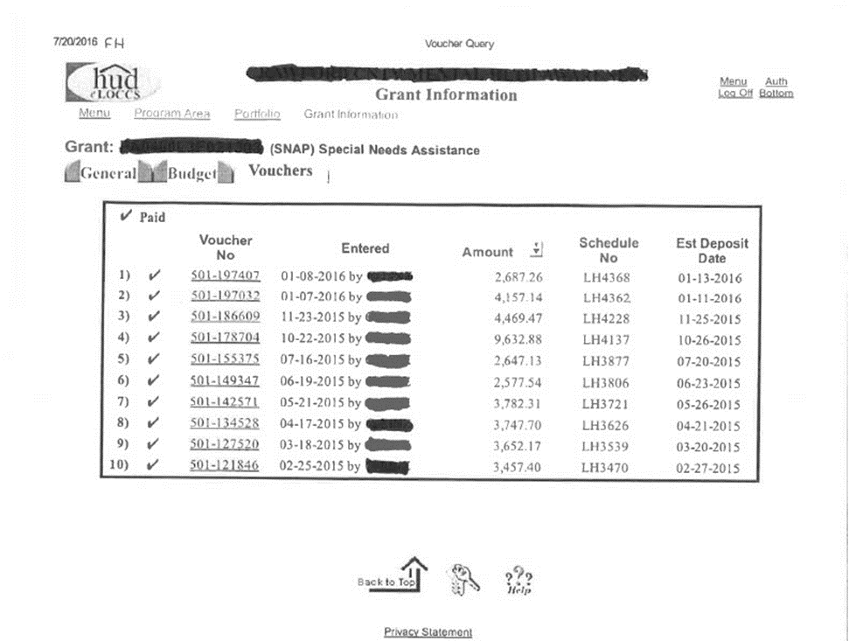

10. Utilization of Grant Funds:
The summary page from eLOCCS that you were instructed to provide in question #9 will be used to score this criterion. Please be sure to include the drawdowns for the entire grant year in your summary page.
If your agency was unable to completely drawdown funds from eLOCCS for the last full grant year, please provide the summary page from eLOCCS showing dates and amounts of drawdowns for the last two full grant years for this project. Please also explain the circumstances that prevented a complete drawdown of funds for consideration in scoring:
Click or tap here to enter text.

11. HMIS Data Quality
To assist in scoring this measure, an HMIS Data Quality Report will be run covering October 1, 2015 to September 30, 2016.
NOTE: DV projects will need to attach a Data Quality Report from their comparable database covering October 1, 2015 to September 30, 2016. Please name the file according to the following naming convention:
“[ProjectName]_11_DV Data Quality Report”
If your project experienced any irregularities that negatively impacted your project’s performance on this measure, you may provide an explanation below for consideration:
Click or tap here to enter text.

12. HUD Monitoring
Please attach any HUD Monitoring Reports and Responses to Findings related to this project from the past 2 years. Please name the file according to the following naming convention:
“[ProjectName]_12_HUD Monitoring_[1]”
If your project experienced any irregularities that negatively impacted your project’s performance on this measure, you may provide an explanation below for consideration:
Click or tap here to enter text.

13. Client data confidentiality policies and procedures
Please attach the agency’s client data confidentiality policies and procedures that cover this project. Please name the file according to the following naming convention:
“[ProjectName]_13_Client Confidentiality”
If your project experienced any irregularities that negatively impacted your project’s performance on this measure, you may provide an explanation below for consideration:
Click or tap here to enter text.

14. Discharge policies/appeals process
Please attach the agency’s client discharge policies/appeals process covering this project. Please name the file according to the following naming convention:
“[ProjectName]_14_Discharge and Appeals”
If your project experienced any irregularities that negatively impacted your project’s performance on this measure, you may provide an explanation below for consideration:
Click or tap here to enter text.

CoC/HUD Policy Priorities & CoC Participation Criteria

15. Housing First
Does the project operate in accordance with the MACCH Housing First Policy? ☐ Yes ☐ No
16. Coordinated Entry
Through its Coordinated Entry process, the CoC is prioritizing resources in order to serve those with the highest needs and in furtherance of the Opening Doors goals:
• Ending Veterans Homelessness
• Ending Chronic Homelessness
• Ending Homelessness Among Families with Children and Youth
As such, all projects are expected to participate in the Coordinated Entry process, as measured by criteria 16a and 16b. (Note: This currently applies only to RRH & PSH projects.)
16a. Coordinated Entry Openings & Referrals – PSH & RRH
N/A for TH
If your agency/project experienced any irregularities or circumstances that negatively impacted your project’s performance on this measure, you may provide an explanation below for consideration:
Click or tap here to enter text.

16b. Coordinated Entry – Participation in Meetings – PSH & RRH
N/A for TH
MACCH Attendance Records for the Coordinated Entry Work Group will be used to score this measure. If your agency participated in the ongoing development of the CE system in additional ways that you would like considered in the scoring, you may describe those efforts below:
Click or tap here to enter text.

If your agency/project experienced any irregularities or circumstances that negatively impacted your project’s performance on this measure, you may provide an explanation below for consideration:
Click or tap here to enter text.

Attachment Checklist:

☐ Criteria 9. eLOCCS Drawdowns & 10. Utilization of Grant Funds:
“ProjectName_ 9-10_eLOCCS Drawdowns”
☐ DV Program Only - Criteria 11. HMIS Data Quality:
“ProjectName_ 11_DV Data Quality Report”
☐ Criteria 12. HUD Monitoring:
“ProjectName_12_HUD Monitoring_[1]”
☐ Criteria 13. Client data confidentiality policies and procedures:
““ProjectName_13_Client Confidentiality”
☐ Criteria 14. Discharge policies/appeals process:
“ProjectName_14_Discharge and Appeals”

